Nº | IMAGEN / IMAGE | LEYENDA / CAPTION
1 | 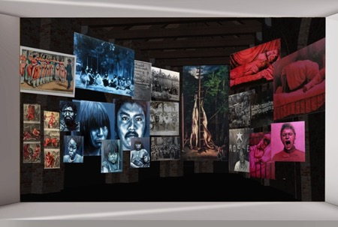 | Voluspa Jarpa  The Subaltern Portrait Gallery, 2019  Installation View.  Altered Views Chilean Pavilion at 58th Venice Biennale.  22 painting. Oil on canvas.
2 | 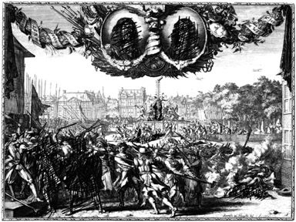 | Voluspa Jarpa  Fragment:  The Dismembered republic  The Hegemonic Museum. Case 1, 2019.  28 copper mold engravings, 10 laser engraved acrylic plaques and steel structure.  145 x 95 x 190 cm
3 | 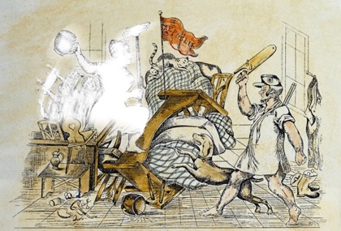 | Voluspa Jarpa  Fragment:  5 scenes  The Hegemonic Museum. Case 2, 2019.  Wooden box, objects, light and figures in laser engraved and painted acrylic  15 x 26 x 8 cm
4 | 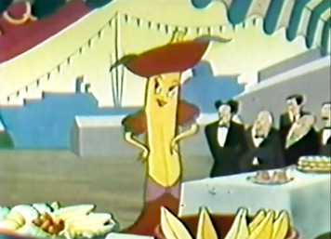 | Voluspa Jarpa  Still  Video 2  The Hegemonic Museum. Case 5, 2019.  Made from the audiovisual publicity for the Chiquita Banana campaign by United Fruit Co in the 40´s.
5 | 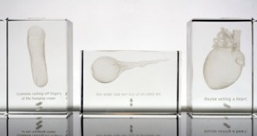 | Voluspa Jarpa  Fragments:  Rampjaar: Redeloos, Radeloos, Reddeloos  The Hegemonic Museum, 2019  Foto: Rodrigo Merino.
6 |  | Voluspa Jarpa  De Witt  The Subaltern Portraits Gallery, 2019  480cm x 290 cm  Foto: Rodrigo Merino
7 | 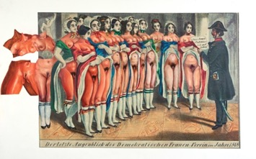 | Voluspa Jarpa  Lips from the Women Club  The Subaltern Portraits Gallery, 2019  136x 216 cm  Foto: Rodrigo Merino
8 |  | Voluspa Jarpa  Insult Vienna 1  The Subaltern Portraits Gallery, 2019  173 x 59 cm  Foto: Rodrigo Merino
9 | 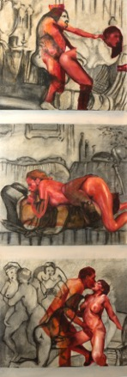 | Voluspa Jarpa  Insult Vienna 2  The Subaltern Portraits Gallery, 2019  173 x 59 cm  Foto: Rodrigo Merino
10 | 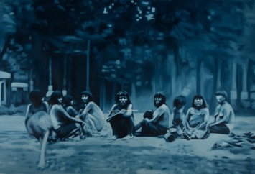 | Voluspa Jarpa  Kahuascar Tribe  The Subaltern Portraits Gallery, 2019  191 x 302 cm.  Photo: Rodrigo Merino
11 | 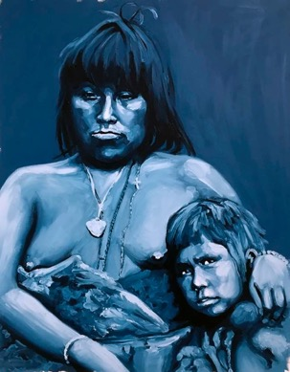 | Voluspa Jarpa  Mother and Son Portrait  The Subaltern Portraits Gallery, 2019  91 x 71 cm.  Photo: Rodrigo Merino
12 | 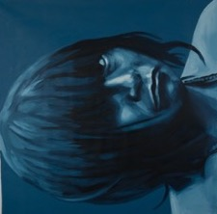 | Voluspa Jarpa  Aborigen Portrait  The Subaltern Portraits Gallery, 2019  91 x 71 cm.  Photo: Rodrigo Merino
13 | 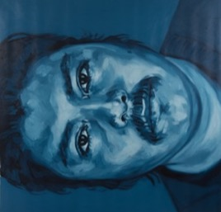 | Voluspa Jarpa  Catrillanca  The Subaltern Portraits Gallery, 2019  208 x 191 cm.  Photo: Rodrigo Merino
14 | 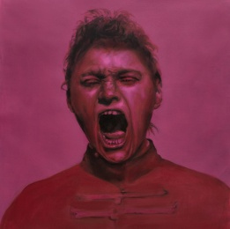 | Voluspa Jarpa  Hysteric Woman Shouting  The Subaltern Portraits Gallery, 2019  120 x 102 cm  Foto: Rodrigo Merino
15 | 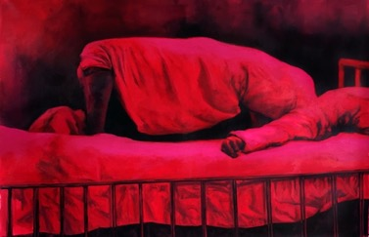 | Voluspa Jarpa  Hysteric Bed  The Subaltern Portraits Gallery, 2019  160 x 242 cm  Foto: Rodrigo Merino
16 | 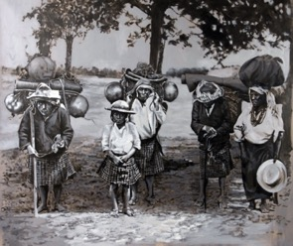 | Voluspa Jarpa  Nahuala Family  The Subaltern Portraits Gallery, 2019  155 x 177 cm  Foto: Rodrigo Merino
17 | 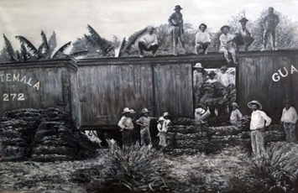 | Voluspa Jarpa  Banana Train  The Subaltern Portraits Gallery, 2019  136 x 206 cm  Photo: Rodrigo Merino
18 | 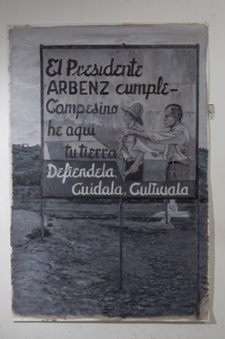 | Voluspa Jarpa  Life Arbenz  The Subaltern Portraits Gallery, 2019  136 x 206 cm  Photo: Rodrigo Merino
19 | 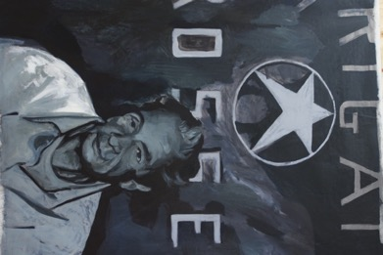 | Voluspa Jarpa  Fragment.  Aldo Moro Portrait  The Subaltern Portraits Gallery, 2019  180 x 196 cm  Foto: Rodrigo Merino
20 | 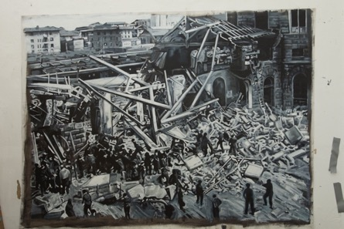 | Voluspa Jarpa  Bologna Attack  The Subaltern Portraits Gallery, 2019  137 x 186 cm  Foto: Rodrigo Merino
21 | 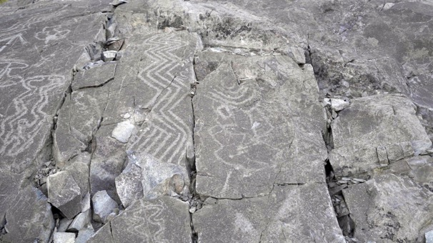 | Voluspa Jarpa  The Emancipating Opera  Still  Video HD  Stereo Sound  Spanish Lyrics / Subtitled in English  11´53´´

22 |  | Voluspa Jarpa  The Emancipating Opera  Still  Video HD  Stereo Sound  Spanish Lyrics / Subtitled in English  11´53´´
23 | 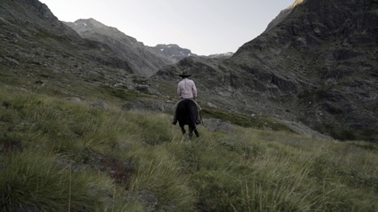 | Voluspa Jarpa  The Emancipating Opera  Still  Video HD  Stereo Sound  Spanish Lyrics / Subtitled in English  11´53´´
24 | 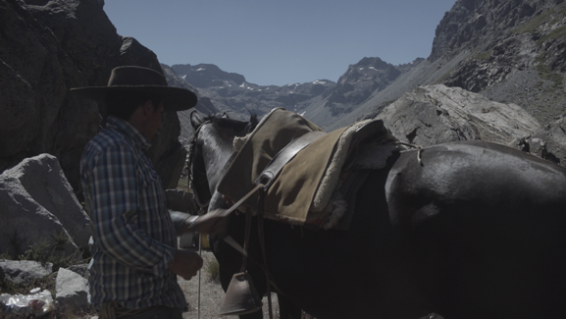 | Voluspa Jarpa  The Emancipating Opera  Still  Video HD  Stereo Sound  Spanish Lyrics / Subtitled in English  11´53´´
25 |  | Voluspa Jarpa  The Emancipating Opera  Still (Daniela Vega)  Video HD  Stereo Sound  Spanish Lyrics / Subtitled in English  11´53´´

26 | 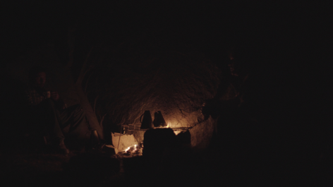 | Voluspa Jarpa  The Emancipating Opera  Still (Daniela Vega)  Video HD  Stereo Sound  Spanish Lyrics / Subtitled in English  11´53´´
27 |  | Voluspa Jarpa  The Emancipating Opera  Still (Daniela Vega)  Video HD  Stereo Sound  Spanish Lyrics / Subtitled in English  11´53´´
28 |  | Voluspa Jarpa  The Emancipating Opera  Still (Daniela Vega)  Video HD  Stereo Sound  Spanish Lyrics / Subtitled in English  11´53´´

